# Exercise: Loops

Test your tasks in the Judge system: <https://judge.softuni.org/Contests/4412>

# For Loop

## Power of Number

Write a program to calculate number raising to a certain power:

* Reads an **integer** **number n** from the console
* Reads an **integer number p** which represents **power** from the console
* Print the result of **n to the power of p**

**Note:** Don't use **Math.Pow()**, use loops

## Example Input / Output

|  |  |  |  |  |  |  |  |
| --- | --- | --- | --- | --- | --- | --- | --- |
| **Input** | **Output** |  | **Input** | **Output** |  | **Input** | **Output** |
| 2  5 | 32 | 3  4 | 81 | 2  3 | 8 |

## Multiplication Table

Write a program that prints a **multiplication table**:

* Reads an **integer number** **n** from the console
* Print a **multiplication table** of size 10 for given integer **n** in the following format:

"**{n} x {i} = {result}**" for each **i** in the range [1…10]

## Example Input / Output

|  |  |  |  |  |  |  |  |
| --- | --- | --- | --- | --- | --- | --- | --- |
| **Input** | **Output** |  | **Input** | **Output** |  | **Input** | **Output** |
| 2 | **2** **x 1 = 2**  **2 x 2 = 4**  **2 x 3 = 6**  **2 x 4 = 8**  **2 x 5 = 10**  **2 x 6 = 12**  **2 x 7 = 14**  **2 x 8 = 16**  **2** **x 9 = 18**  **2** **x 10 = 20** | 3 | **3** **x 1 = 3**  **3 x 2 = 6**  **3 x 3 = 9**  **3 x 4 = 12**  **3 x 5 = 15**  **3 x 6 = 18**  **3 x 7 = 21**  **3 x 8 = 24**  **3** **x 9 = 27**  **3** **x 10 = 30** | 5 | **5** **x 1 = 5**  **5 x 2 = 10**  **5 x 3 = 15**  **5 x 4 = 20**  **5 x 5 = 25**  **5 x 6 = 30**  **5 x 7 = 35**  **5 x 8 = 40**  **5** **x 9 = 45**  **5** **x 10 = 50** |

## Biggest Number

Write a program to find **the biggest** among given **n** numbers:

* Read an integer number **n** (the **amount** of input numbers) and **n** integer numbers from the console
* Find and print the **biggest** number

## Example Input / Output

|  |  |  |  |  |  |  |  |
| --- | --- | --- | --- | --- | --- | --- | --- |
| **Input** | **Output** |  | **Input** | **Output** |  | **Input** | **Output** |
| 3  40  90  50 | 90 | 4  -40  -3  -90  -50 | -3 | 2  1  7 | 7 |

## Vowel Sum

Write a program to **sum N vowels**, according to the table below:

* Read an integer number **N**: the count of characters
* Read **N characters** and for each vowel character adds its value from the table to the result

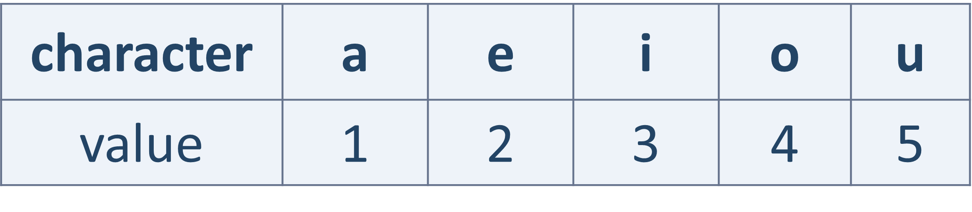

## Example Input / Output

|  |  |  |  |  |  |  |  |
| --- | --- | --- | --- | --- | --- | --- | --- |
| **Input** | **Output** |  | **Input** | **Output** |  | **Input** | **Output** |
| 2  a  e | 3 | 3  i  x  u | 8 | 3  o  g  a | 5 |

## Division to 2, 3 and 4

Write a program to find **statistics about division to 2, 3 and 4**:

* Read an **integer number N** and **N** integers from the console
* Find in **percentages** how many of these integers can divide without a remainder to numbers **2**, **3** and **4**
* Print the percentages, formatted to the **second** decimal digit:
  + On the first line print **percent** of the numbers that are **divisible by 2**
  + On the first line print **percent** of the numbers that are **divisible by 3**
  + On the first line print **percent** of the numbers that are **divisible by 4**

## Example Input / Output

|  |  |  |  |  |
| --- | --- | --- | --- | --- |
| **Input** | **Output** |  | **Input** | **Output** |
| 3  3  6  9 | 33.33%  100.00%  0.00% | 3  4  6  3 | 66.67%  66.67%  33.33% |

# While Loop

## Special Number

Write a program to check if given number is **special**:

* + **Special numbers are divisible by all of their digits without remainder**
  + Reads an integer number and check whether it is a special number
  + If the number **IS** special print: "**{num} is special**"
  + If the number is **NOT** special print: "**{num} is not special**"

**Note:** There will not be numbers with digit 0 in them.

## Example Input / Output

|  |  |  |  |  |
| --- | --- | --- | --- | --- |
| **Input** | **Output** |  | **Input** | **Output** |
| 23 | 23 is not special | 212 | 212 is special |

## Special Bonus

Write a program to apply a **20% bonus** for certain number:

* + Reads **an integer number** from the console: the "**stop number**"
  + Keep **reading integers** until it finds the **stop number**
  + When the **stop number** is found, increase the value of the **previous** number **before it** with **20%** and print it

## Example Input / Output

|  |  |  |  |  |
| --- | --- | --- | --- | --- |
| **Input** | **Output** |  | **Input** | **Output** |
| 25  20  30  25 | 36 | 14  6  10  14 | 12 |

## Account Balance

Write a program to calculate an **account balance**:

* + Read a sequence of **incomes** / **expenses**, until "**End**" is read
  + Add the money to the balance (starting form 0)
  + Print "**Increase: {money}**" or "**Decrease: {money}**", where value is formatted to the **second** decimal digit
  + Finally, print the **account balance,** formatted to the **second** decimal digit in the following format: "**Balance: {account balance}**"

## Example Input / Output

|  |  |  |  |  |
| --- | --- | --- | --- | --- |
| **Input** | **Output** |  | **Input** | **Output** |
| 500  15.5  -80.35  End | Increase: 500.00  Increase: 15.50  Decrease: 80.35  Balance: 435.15 | 200  300  -100  End | Increase: 200.00  Increase: 300.00  Decrease: 100.00  Balance: 400.00 |